realme TechLife Watch R100 Use Manual

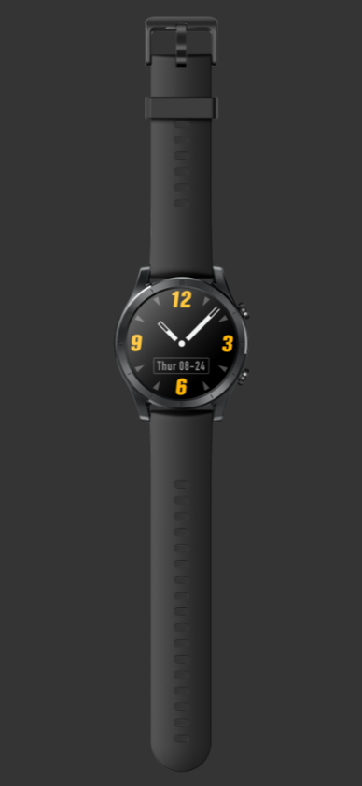

CONTENTS
1. Quick Start 3
1.1 Wear the Watch 3
1.2 Change the Strap 3
1.3 Connect the Watch to Your Phone 3
1.4 Power On/Off and Reboot 4
1.5 Charge the Watch 5
1.6 Physical Buttons and Screen Control Gestures 6
1.7 Set the Time and Language 7
1.8 Set Quick Applications 8
1.9 Set Widgets 8
1.11 Enable the DND Mode 8
1.12 Upgrade the Watch and App 9
1.13 Factory Reset 9
2. Application Management 10
2.1 Message Reminder and Delete Messages 10
2.2 Make/Answer Calls on the Watch 10
2.3 Answer/Reject Calls 11
2.4 Check the Call History 11
2.5 Music 12
2.6 Weather 12
2.7 Alarm 12
2.8 Stopwatch 13
2.9 Timer 13
2.10 World Clock 14
2.11 Flashlight 14
2.12 Find My Phone 14
3. Scientific Exercise 14
3.1 Exercise 14
3.2 Automatic Recognition of Exercise 15
3.3 Daily Exercise 16
4. Health Management 16
4.1 HR 16
4.2 SpO₂ 18
4.3 Sleep 18
4.4 Stress 19
4.5 Breath Training 19
5. Alexa 20
5.1 About Alexa 20

1. Quick Start

1.1 Wear the Watch
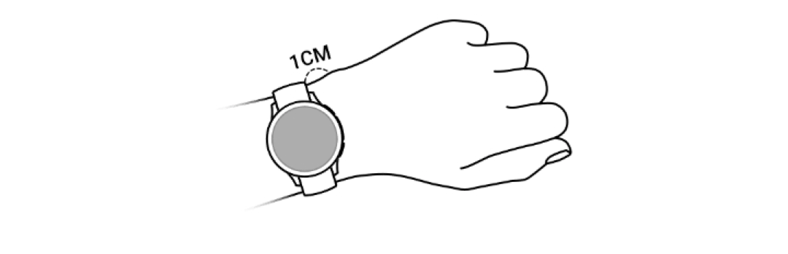

1.2 Change the Strap
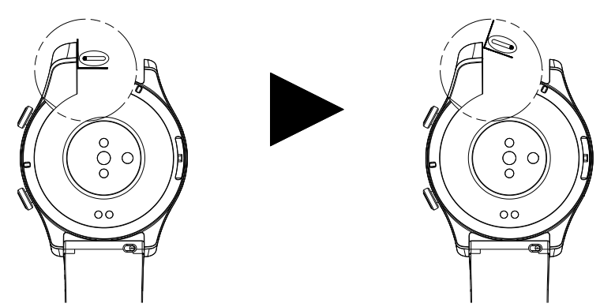

1.3 Connect the Watch to Your Phone
Before using the watch for the first time, you need to connect the watch to the charger to activate it. The watch will vibrate and display the QR code. Please start the “realme Wear” App and scan the QR code to bind the watch (the OSD language of the watch is identical with the system language by default). If the battery voltage of the watch is low, please charge the watch to a battery level of 10% or higher through the charging cable.

- Pairing steps for Android user:
- Search for “realme Wear” in Google Play and download and install the realme Wear App, or update the existing one on your phone to the latest version.
- Start the realme Wear App, register an account and log into the App, and then enable the relevant permissions according to the pop-up prompts. Click [Device] → [Add Device] and scan the QR code displayed on the watch screen (or click the Bluetooth name of the watch). A dialog box will pop up on your phone, which asks whether you are sure to start pairing. Click “Yes” and follow the prompts to complete pairing.

- Pairing steps for iOS user:
- Search for “realme Wear” in App Store and download and install the realme Wear App, or update the existing one on your phone to the latest version.
- Start the realme Wear App, register an account and log into the App, and then enable the relevant permissions according to the pop-up prompts.

Note:
  - Upon successful pairing, the watch will show the pairing success screen and synchronize the relevant information (date, notifications, etc.) of your phone.
  - In case of unsuccessful pairing, the watch will show the pairing failure screen and return to the boot screen.
  - A watch can be connected to only one phone at one time. If you want to connect it to another phone, please go to [Device] → [Device Manage] in the App to delete the watch, and then unpair the watch in the Bluetooth device list of your phone.

1.4 Power On/Off and Reboot
Power On
- In power-off state, press and hold the lower key to turn on the watch; or
- In power-off state, the watch will be turned on automatically when connected to the charger.

Power Off
- In power-on state, press the upper key to access the application list, and then select “Setup→Power Off”.
- In case of very low battery voltage, the watch will automatically shut down after reminding you by vibrating.

Reboot
- In power-on state, press the upper key to access the application list, and then select “Setup→Reboot”.

Forced Reboot
- During the charging process, press and hold the lower key to force the watch to reboot.

Factory Reset
- In power-on state, press the upper key to access the application list, and then select “Setup→Factory Reset”.

1.5 Charge the Watch
Charging
- Connect the power adapter to the charging cable.
- Make the charging contacts of the charging cable fit well with the charging contacts of the watch (at the bottom case), until the charging indicator appears on the watch screen.
- When the watch becomes fully charged, the charging indicator will show 100%, and the watch will automatically stop charging.

Note:
- Please use the charging cable supplied with the watch and a charger with a rated output voltage of 5V and current of 1A or above to charge the watch. A fast charger (9V or above) may cause damage to the watch.
- After the watch shuts down automatically due to low battery voltage, it will be turned on automatically when connected to the charger.

Charging Time
The watch can be fully charged in two hours. The watch is fully charged when the charging indicator shows 100%, then disconnect the charger promptly.
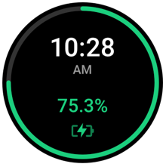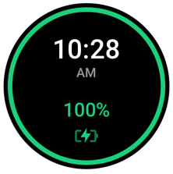

Note:
- Please charge the watch in a dry and well-ventilated environment.
- Before charging the watch, please dry the charging contacts to avoid short circuit or other risks caused by dirt or moisture.
- Before charging the watch, please keep the charging contacts of the charging cable and the watch dry by wiping off water and sweat (if any).
- The recommended ambient temperature is 0°C~45°C.
- In order to protect the battery life of the watch, the charging current will be reduced in a cold low-temperature environment. In this case, the charging time may be longer, but the battery life will not be affected.

Check the Battery Level
You can check the battery level of the watch by the following methods.
Method 1: the watch will automatically recognize your charging scenario; when the watch is connected to the power supply, the charging indicator will show the battery level.

Method 2: go to “Device” page in the realme Wear App to check the battery level.
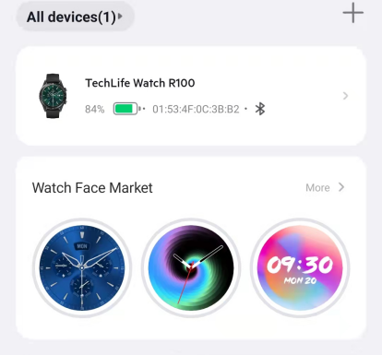

1.6 Physical Buttons and Screen Control Gestures
The watch is equipped with a color screen, supporting full-screen touch operations such as swipe-up, swipe-down, swipe-left, swipe-right, press-and-hold.
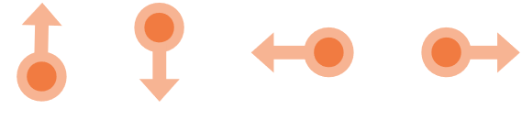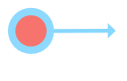
Upper key
Operation | Function | Remarks
Press | 1. In screen-off state, press the upper key to turn on the screen.  2. On the watch face, press the upper key to access the application list.  3. On a screen other than watch face, press the upper key to return to the watch face. | Except as otherwise defined in such applications as Call, Sports, Timer, and Stopwatch.
Press and hold | Press and hold the upper key to start Alexa.

Lower key
Operation | Function | Remarks
Press | Press the lower key to go to “Sports” (default). | Except as otherwise defined in such applications as Call and Sports.
Press twice | Press the lower key twice to go to “Outdoor Run” (default).
Press and hold | During the charging process, press and hold the lower key to force the watch to reboot.
Screen Control Gestures
Operation | Function
Press | To select and confirm.
Press and hold | On the watch face, press and hold the shortcut to change the watch face.
Swipe down | On the watch face, swipe down to view notifications.
Swipe up | On the watch face, swipe up to view the shortcut menu.
Swipe left/right | To view such cards as exercise and data, HR curve, stress wave, weather and music.
Swipe right | To return to the previous screen.

Screen On
- Press the upper key to turn on the screen; or
- Raise or turn your wrist inward to turn on the screen.

Screen Off
- In screen-on state, lower or turn your wrist outward to turn off the screen.
- In screen-on state, if no user operation is performed, the screen will be turned off automatically in 5s (default). The screen-on time can be adjusted.
- Press the upper key to access the application list. Select “Setup→Screen-on Time” and swipe up/down to select a screen-on time (default: 5s).

1.7 Set the Time and Language
- You do not need to set the time on your watch. After the watch is connected to your phone, the time on your phone will be automatically synchronized to the watch.
- If you change the time on your phone after the watch is connected to your phone via Bluetooth, the time on your watch will be changed synchronously.
- To set the OSD language of the watch, start the “realme Wear” App, select “Device→Device Language” and then select a desired language (the OSD language of the watch is identical with the system language by default).

1.8 Set Quick Applications
After the watch is paired successfully with the realme Wear App, you can go to “Device→More Settings→Quick Applications” to enable at least two of the following cards so as to experience the corresponding functions.
- HR
- Stress
- Weather
- Health Data
- Music Control

1.9 Set Widgets
After the watch is paired successfully with the realme Wear App, you can go to “Device→More Settings→Widgets” to edit the following widgets (default) so as to experience the corresponding functions. Please enable at least one widget.
- Fitness
- Call
- SpO₂
- Alexa
- HR
- Stress
- Weather
- Sports

1.11 Enable the DND Mode
On the watch face, swipe up to open the shortcut menu, and then enable "DND" to activate the “Do Not Disturb” mode.
If "DND” is enabled:
1. Incoming calls will not be displayed on the watch or reminded by turning on the screen or vibrating.
2. Messages and notifications will be displayed on the watch, but will not be reminded by turning on the screen or vibrating. The screen will not be turned on when your wrist is raised.
Note:
- DND period: when “DND” is enabled, you can set the DND period manually in the realme Wear App.
- On the watch face, swipe up to open the shortcut menu, and then press “DND” to activate the DND mode.

1.12 Upgrade the Watch and App
Update the App:
After the watch is connected to your phone via the realme Wear App, you can select “My→Check for Updates” in the App so as to search for update packages automatically.
Update the watch firmware:
After the watch is connected to your phone via the realme Wear App, you can select “Device→Device Manage→Device Upgrade” in the App and click “Upgrade Now” to update the firmware. When an update package is detected, the word "new" will appear on the page.
Note:
- When you start updating the App, the watch will be automatically disconnected from the Bluetooth of your phone. Please wait patiently until the upgrade progress displayed on your phone indicates that the upgrade is completed.
- When updating the firmware, you need to maintain the Bluetooth connection between the watch and your phone, and keep the battery level of the watch at 35% or above. Please wait patiently until the upgrade progress displayed on the watch indicates that the upgrade is completed.

1.13 Factory Reset
Press the upper key to access the application list, and then select “Setup→Factory Reset” to reset the watch to factory defaults. Think twice before performing this operation, because it will clear all your data.

2. Application Management

2.1 Message Reminder and Delete Messages
Message Reminder
1. After the watch is paired and connected to the realme Wear App, you can go to the App to select “Device→Notification and Reminder”, and then turn on “Message Reminder” and select the applications from which you want to receive messages.
2. When a new message appears in the status bar of your phone, the watch will remind you by vibrating.
3. You can swipe the screen down to read the message. The watch can store up to 100 unread messages. When the 101st message is received, the earliest message will be overwritten. Each message will be fully displayed on one screen.
Note:
- If a message appears in the notification bar of your phone, it will be pushed when the phone screen is turned on and unlocked.
- Messages supported by the watch: SMS, E-mail, calendar, WeChat and QQ (or other social applications) messages (WeChat or QQ voice calls will be reminded, but cannot be answered or hung up).
- You cannot reply to SMS, WeChat or E-mail messages directly on the watch.
- If the DND mode is enabled, the watch can still receive messages, but will not remind you by turning on the screen or vibrating.
- If a new message arrives while you are reading a message, the serial number of the new one will be displayed.
- After the watch is connected to your phone via Bluetooth, the calls and messages received on your phone will be transferred to the watch via Bluetooth. There is a certain delay in message transfer via Bluetooth, which cannot be reminded simultaneously.
- If your phone is connected to both watch and other Bluetooth device, the message reminder and call reminder function of the watch will not be affected.
- WeChat/QQ voice messages and picture messages can be received on the watch, but cannot be listened to or viewed on the watch.

Delete Messages
You can slide a read message left and then delete it, or click “Clear All” at the top of the message list to clear all unread messages.

2.2 Make/Answer Calls on the Watch
Set Frequent Contacts
- In the realme Wear App, select “Device→Call→Frequent Contacts”.
2. On “Frequent Contacts” page, you can perform the following operations:
Click “Add” to access the contact list of your phone, and then select a contact to add it to frequent contacts.
Click “Edit”, and then press and hold a frequent contact to delete it.
3. On the watch, press the upper key to access the application list, select “Call→Frequent Contacts”, and then click a frequent contact to make a call.
Note:
- You can add up to 10 frequent contacts.
- To make a call to a frequent contact on the watch, you need to connect the watch to the App and complete Bluetooth pairing between the watch and your phone. If the watch is connected to the App, but not paired with the Bluetooth of your phone, the watch will remind you of incoming calls, but will not support making or answering calls.
- During a call, you can click the speaker icon to adjust the call volume.
- The watch can store up to 40 call records.

Dial Pad
Press the upper key to access the application list, select “Call→Dialpad”, enter the phone number and click the phone icon to make a call.

2.3 Answer/Reject Calls
After the watch is connected to your phone, when there is an incoming call on your phone, the watch will display the caller's phone number or name and remind you by ringing and vibrating. You can choose to answer or reject the call.
Note:
- If the caller is an existing contact, the caller’s name saved on your phone will be displayed on the watch. For an unfamiliar caller, the watch will display the caller’s phone number.
- If the DND mode is enabled, the watch will not receive incoming calls, and will not remind you by turning on the screen and vibrating.
- You can press the upper key to stop the vibration of the watch.
- You can click the Hang Up button on the watch screen to reject or end a call.

2.4 Check the Call History
1. Press the upper key to access the application list, and select “Call→Call History” to view the call records.
2. Click a call record to call back.
3. Swipe right to return to the Call screen.

2.5 Music
After the watch is connected to the realme Wear App, you can swipe up to open the shortcut menu on the watch face, and then select “Music” to go to the music control page.
Note:
The default music App on your phone will be started on the watch.

2.6 Weather
The watch can display the weather information of your current location.

Press the upper key to access the application list, and select “Weather” to display the weather data: city + date + current temperature + temperature range (lowest temperature and highest temperature of the day) + refresh interval.
Note:
- Rules for not displaying the Weather application: if you select “Quick Applications” in the App and add “Weather”, the Weather application will appear on the corresponding primary page; if you do not add “Weather” in the App, the Weather application will not appear on the corresponding primary page.
- Displaying the Weather application, but displaying no weather data: if the weather push function is enabled in the App (enabled by default), the watch will display the weather data synchronously; if disabled, the watch will show “No data”; if the weather data is cleared or not acquired, the watch will show “No data” too.
- In the App, you can change the temperature unit between °C and °F. Such changes will be synchronized to the watch. Display range of temperature: -99~999 (°C/°F).
- Your current location (city) is acquired based on the App.
- Data update time: indicated as “XX hours ago” (more than one hour) or “XX minutes ago” (less than one hour).

2.7 Alarm
- Press the upper key to access the application list, select “Clock→Alarm” and click “+” to add an alarm.
- You can also go to the realme Wear App to select “Device→Alarm” and add alarms. Then you can press and hold an alarm to delete it (when necessary).
- Create an alarm: select the alarm time and click “√”, select the working dates and click “√”.
- Click an alarm to edit, modify or delete it.
- When the alarm rings and vibrates, you can click the sleep icon (Z^{Z}) or press the upper key or lower key to delay the alarming time by 10min. You can also click "×" to stop the alarm.
Note:
- Press the upper key to access the application list, select “Setup” and adjust the “Ring Volume” and “Vibration Mode”, so that you can wake up more comfortably from sleep.
- If you do not select working dates for an alarm, it will work only once.
- You can add up to 10 alarms.
- If no user operation is performed in an alarming time of 60s, the alarm will be delayed automatically. An alarm can be delayed up to three times. It will no longer work after three delays.
- On the watch face, swipe up to open the shortcut menu, and then click "Alarm” to go to the Alarm page.
- Each alarm (up to 10 alarms) added by Alexa is marked with “Alexa”. If you try to add the 11th Alexa alarm, a prompt message will appear on the Alexa Alarm page. Alexa alarms can only be edited by Alexa.

2.8 Stopwatch
1. Press the upper key to access the application list, click “Clock→Stopwatch”, and then click the start icon to start the stopwatch. Click the pause icon to pause the stopwatch. In paused state, click the reset icon to reset the stopwatch. Click the stopwatch icon to end a round.
2. Swipe right on the screen or press the upper key to exit the Stopwatch page.
Note:
- After the stopwatch is started, you can press the lower key to end a round.
- The stopwatch supports up to 99 rounds, which will be displayed in sequence (the most recent round will be displayed at the top).
- Time format of the stopwatch: “min:sec.ms”.

2.9 Timer
1. Press the upper key to access the application list and click “Clock→Timer”. The watch provides six countdown timers by default (1min, 3min, 5min, 10min, 30min, 60min). You can choose a timer based on your actual needs.
2. You can also customize the timer. Click “+” on the top of the Timer page, swipe up or down to select a countdown time, and then click the start icon to start the timer; if necessary, you can click the pause icon to pause the timer, or click the stop icon to stop the timer.
3. Swipe right on the screen or press the upper key to exit the Timer page.
Note:
- Click an existing timer to start it directly.
- The timer cannot run in the background.

2.10 World Clock
Press the upper key to access the application list, click “Clock→World Clock” to go to the World Clock page.
Note:
- The clock can be switched among four time zones (Beijing, New York, London, Tokyo) by default.
- In the App, click “Device→More Settings→World Clock” to add other time zones (up to 10 times zones). You need to enable at least one time zone.

2.11 Flashlight
On the watch face, swipe up to open the shortcut menu, and then click “Flashlight” to turn on the flashlight.
Note:
- The screen is lighted at high brightness. Tap the screen to adjust the flashlight brightness among High, Medium and Low. Swipe right on the screen or press the upper key to quit the Flashlight application.

2.12 Find My Phone
1. On the watch face, swipe up to open the shortcut menu, and then click “Find My Phone” to go to “Find My Phone” page.
2. When your phone is found, tap the watch screen to pause the ring of your phone, or press the upper key or swipe right to exit the “Find My Phone” function.
Note:
- To use the “Find My Phone” function, please maintain the Bluetooth connection between the watch and your phone.
- Your phone will ring even in a muted or DND mode.

3. Scientific Exercise
The watch supports a variety of sports. You can choose your own exercise mode based on your actual scenarios.

3.1 Exercise
1. Press the upper key to access the application list, select “Sports”, and then select a sport based on your needs.
2. Before starting an exercise, you can click “...” to set your goals of “Duration”, “Calories” and “Distance” and enable or disable “Virtual Accompanying Runner” (available for outdoor running only).
3. During an exercise, you can press the upper key to pause the exercise; swipe up or down to view your exercise data; swipe left to go to the music control page; swipe right to go to the stop/pause exercise page.
We take outdoor running as an example: during the exercise, you can view such data as the calorie consumption, duration, distance, average pace, average HR, stride frequency and aerobic training effect (different sports correspond to different exercise data).
4. At the end of an exercise, you can click “Sports” in the application list to view your exercise records. After synchronizing your data to the realme Wear App, you can also click “Exercise Records” on the Home screen of the App to view your exercise records.
Note:
- If your movement distance or exercise time is too short, no data of this exercise will be recorded.

3.2 Automatic Recognition of Exercise
In the realme Wear App, select “Device→More Settings→Sports Intelligence”. “Sports Intelligence” is currently available for running and walking only.
Auto Pause Exercise
If you enable this function, the watch will pause the data recording when it detects that you have stopped moving during a running/walking exercise. It will resume the data recording when you continue to move.
Auto Stop Exercise
If you enable this function, the watch will ask you whether to stop the exercise or not when it detects that you have stopped moving. If you continue to move, the exercise will be resumed; if you do not respond, the exercise will be stopped automatically in 10s.
Note:

- Sports Intelligence: when the watch detects that you have been running/walking for X minutes, it will determine that you are running/walking, and display the corresponding message to remind you (for running, X=2min; for walking, X=5min).
- In the App, you can enable/disable “Sports Intelligence” for an individual sport. It is enabled only for running by default. (“Sports Intelligence” is disabled by default before the watch is bound to the App.)
- When a different sport is detected, the exercise recognition message will be changed accordingly (for example, after your running is recognized, if you start walking for 5min, the walking recognition message will pop up, instead of the previous running recognition message).
- After the exercise mode is activated, no exercise recognition message will be triggered.
- If you click “Cancel Reminder”, no exercise recognition message will appear in 30min; from the 31st minute, if the watch detects that you have been moving for X minutes, it will remind you again. After the exercise mode is activated, this reminder will not be triggered.

3.3 Daily Exercise
The watch uses the acceleration sensor and gyroscope sensor to recognize and monitor your diverse movements throughout the day, and supports the statistics and display of your steps, exercise duration, calorie consumption, number of exercises, distance, and stairs climbed.
Wear the watch correctly, and the watch will automatically record your steps, exercise duration, calorie consumption, number of exercises, distance and other related data into your daily exercise data.
You can view your exercise data using the following methods.
Method 1 — on the watch:
Press the upper key to access the application list, or swipe right on the watch face, and then select “Exercise”. Swipe up or down to view your data such as steps, exercise duration, number of exercises and calorie consumption.
Method 2 — in the realme Wear App:
You can check your daily exercise records on the Home screen of the realme Wear App.
Note:
- To check your daily exercise data in the realme Wear App, please connect the watch properly to the realme Wear App.

4. Health Management

4.1 HR
The watch is equipped with a wrist-type optical HR sensor, which supports 24-hour continuous HR monitoring and recording, helping you stay healthy in a scientific manner.

4.11 Manual HR Measurement

1. Wear the watch comfortably in a resting state.
2. Press the upper key to access the application list, and select “HR” to measure your current HR value.
3. Swipe right on the watch screen to stop the HR measurement.
4. Intelligent HR measurement is enabled by default.
Note:
- Under normal circumstances, the HR value will be output in 15s.
- To ensure the accuracy of HR measurement, please wear the watch correctly (not around wrist joints; not too loose; tight enough during exercise). Make sure the HR sensing area fits well with your skin and is not blocked by foreign objects.
- Valid range of HR: 35~210. Any HR value beyond the valid range will not be displayed.

4.12 Automatic HR Measurement

The watch supports 24-hour HR monitoring (intelligent HR measurement is enabled by default). If continuous HR monitoring is not enabled, go to the realme Wear App to select “Device→Health Track→HR→Continual HR Measure”, and then select “Real-time Measure”.

Intelligent measurement:
1. Measure your HR value every 5min in a resting state. Each measurement lasts 30s.
2. Measure your HR value every 1s during an exercise. It will take 6s~10s to output the first measurement result.

Real-time Measurement:
Measure your HR value every 1s, regardless of your exercise intensity.
If you enable this function, the watch will measure your real-time HR value continuously. You can view the HR histogram in the HR application (on the watch) or in the realme Wear App.
Note:
- Enabling real-time HR measurement will increase the power consumption of the watch. You can adjust the HR measurement cycle based on your exercise intensity so as to save power.

4.13 High HR Reminder
The watch will remind you when your HR value in a resting state goes out of the predetermined range.
- In the realme Wear App, select “Device→Health Track→HR→Allow Notifications→High HR” and turn on the High HR reminder.
- Click “High HR Value” to set the reminder range and click [OK].
Note:
- Turn on “HR Reminder Off” in the realme Wear App, and the RHR reminder will not be triggered.
- In a resting state, if your HR value has been higher than the predetermined limit for over 10min, the High HR reminder will be triggered.

4.14 Low HR Reminder
The watch will remind you when your HR value in a resting state goes out of the predetermined range.
- In the realme Wear App, select “Device→Health Track→HR→Allow Notifications→Low HR” and turn on the Low HR reminder.
- Click “Low HR Value” to set the reminder range and click [OK].
Note:
- Turn on “HR Reminder Off” in the realme Wear App, and the RHR reminder will not be triggered.
- In a resting state, if your HR value has been lower than the predetermined limit for over 10min, the Low HR reminder will be triggered.

4.2 SpO₂
1. Wear the watch correctly in a resting state.
2. Press the upper key to access the application list, and select “SpO₂” to measure your current SpO₂ level.
3. If you wear the watch incorrectly or do not wear the watch, please wear the watch correctly according to the pop-up message.
Note:
- If you swipe right on the watch screen, or when the alarm time is up or there is an incoming call, the measurement will be interrupted.
- To ensure the accuracy of SpO₂ measurement, please wear the watch correctly (not around wrist joints, not too loose). Make sure the bottom case of the watch fits well with your skin and is not blocked by foreign objects.
- Keep your body still during the measurement.
- Each SpO₂ measurement lasts about 30s.
- During the SpO₂ measurement, the watch will perform a HR measurement simultaneously.

4.3 Sleep
Wear the watch before falling asleep, and the watch will automatically identify when you fall into sleep and wake from sleep, as well as your deep sleep and light sleep time. Your sleep data can be synchronized to and viewed in the realme Wear App.
1. Your sleep data of the day can be displayed on the watch. Press the upper key to access the application list, select “Sleep” and swipe up to view your sleep data.
2. You can view your historical sleep data in the realme Wear App. On the Home screen of the realme Wear App, select “Sleep” to display your historical sleep data, including your daily, weekly, monthly and yearly data.
Note:
- Your sleep will be recorded only if you have been sleeping for more than three hours. Your wake-up time will be recorded only if you have been awake from sleep for more than one hour. The watch can identify your temporary wake-up.
- “Wake up” is not limited to getting out of bed. Staying in bed and playing with mobile phone after waking up is also considered as “wake up”.
- “Wake up” means you have been awake from sleep for more than one hour.
- Your sleep will be detected day and night (24-hour detection). More than three hours of sleep can be recognized. More than one hour of wake-up can be recognized. The watch can recognize multiple sleeps a day.

4.4 Stress
The watch supports manual stress measurement and automatic stress measurement.
Manual stress measurement:
Press the upper key to access the application list, and select “Stress” to perform a stress measurement.
Automatic stress measurement:
In the realme Wear App, select “Device→Health Track→Stress” and enable [Automatic Stress Measure]. Wear the watch correctly every day, and the watch will automatically measure your stress level when measuring your HR value.
View your stress data:
Press the upper key to access the application list, select “Stress” to view your daily stress trend, including the stress level and stress distribution throughout the day, and the stress histogram for the last 30 days.
Note:
- Please wear the watch correctly, and keep your body still during the stress measurement.
- When you are exercising or your wrist is moving frequently, the watch cannot assess your stress level accurately. In this case, the watch will not perform stress measurements.
- Consumption of caffeine, nicotine, alcohol and some psychotropic drugs can affect the accuracy of stress measurement. In addition, the asthma, heart diseases, physical activities or the body pressure at the wearing position can also affect the stress measurement results.
- This product is not a medical device. The measurement results are provided for reference only.
4.41 High Stress Reminder
Appropriate stress is helpful for your physical and mental health, but too much stress will have adverse effects on your health. The watch supports 7×24h real-time stress measurement, keeping you aware of your real-time stress level. The watch will remind you when your stress level in a resting state goes out of the predetermined range.
Note:
- If you enable this reminder, the watch will remind you to relax when your stress level is 80 or higher.

4.5 Breath Training
Breath training can help you relax and ease your mood in stressful work or life.
1. Press the upper key to access the application list and select “Breath Training”.
2. Set the duration and frequency of breath training.
3. Wear the watch and keep your arm still. Then click the start icon and follow the instructions displayed on the screen to exhale and inhale.
4. At the end of the breath training, you can view your current HR data.

5. Alexa

5.1 About Alexa
1. Speak your voice commands (weather query, online Q&A, etc.) on the watch, and they will be executed through Amazon platform.
2. To use the Alexa function, you need to log into your Amazon account in the realme Wear App.
3. To start Alexa, you can press the upper key to access the application list and select “Alexa”, or press and hold the upper key.
Note:
- Alexa may not work if:
- You do not log into your Alexa account in the App;
- The Bluetooth connection between the watch and App is lost; or
- Your phone is not connected to the Internet, or its Internet signal is poor.

