OPPO Band Service Manual

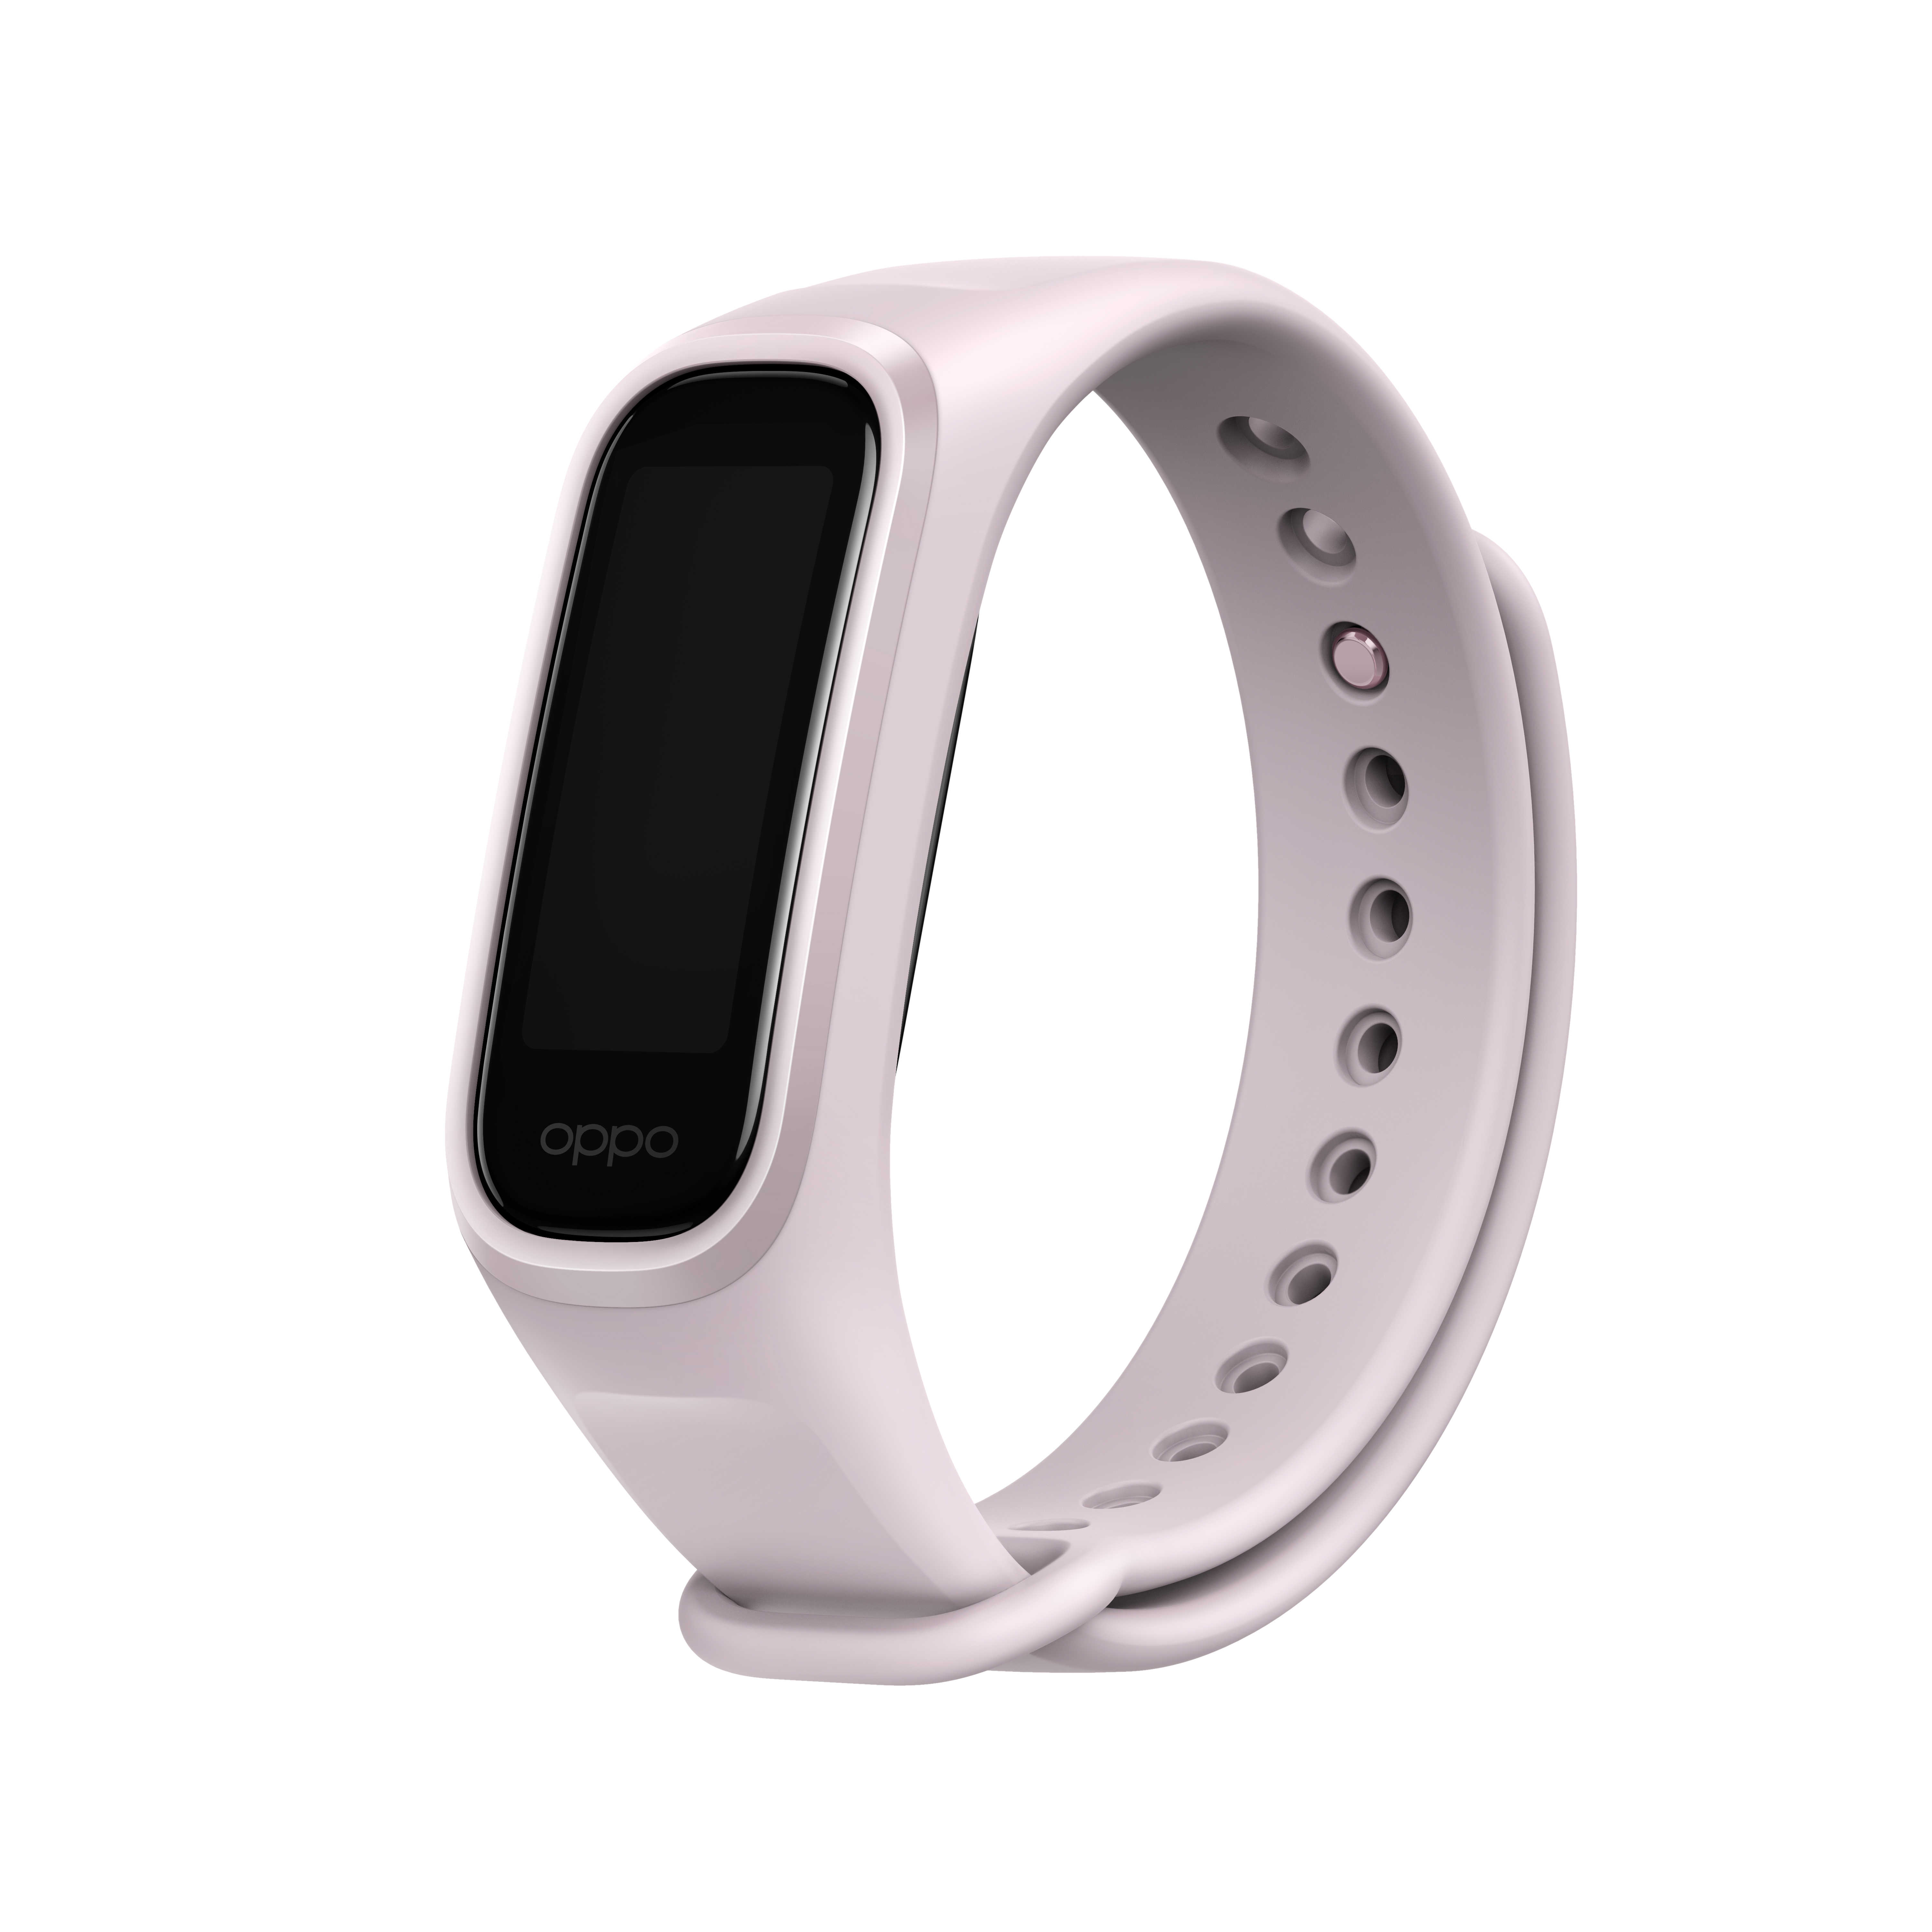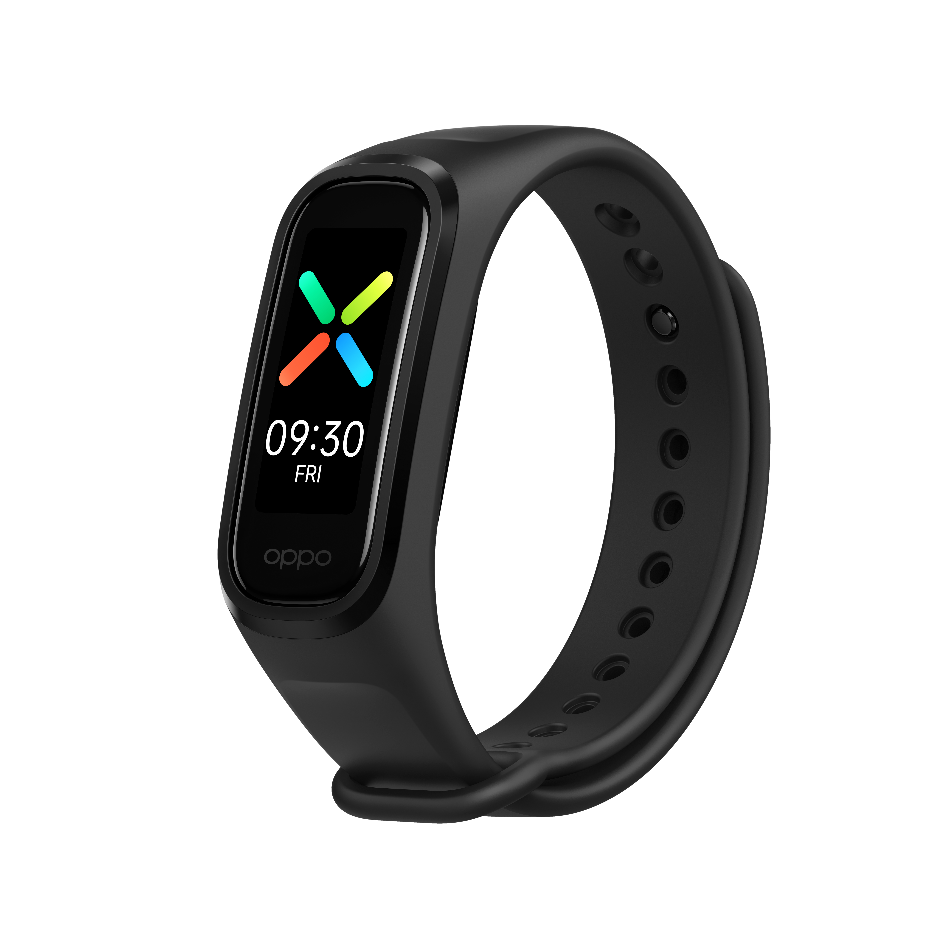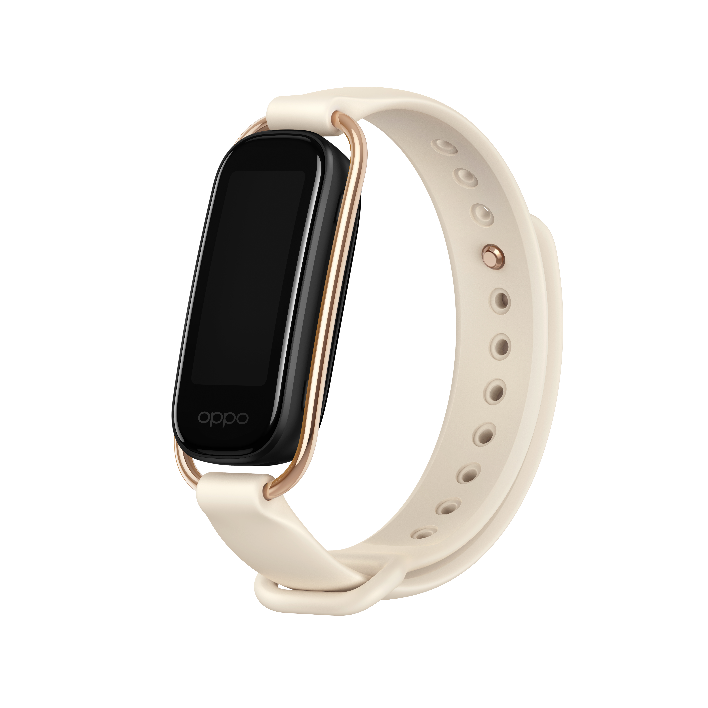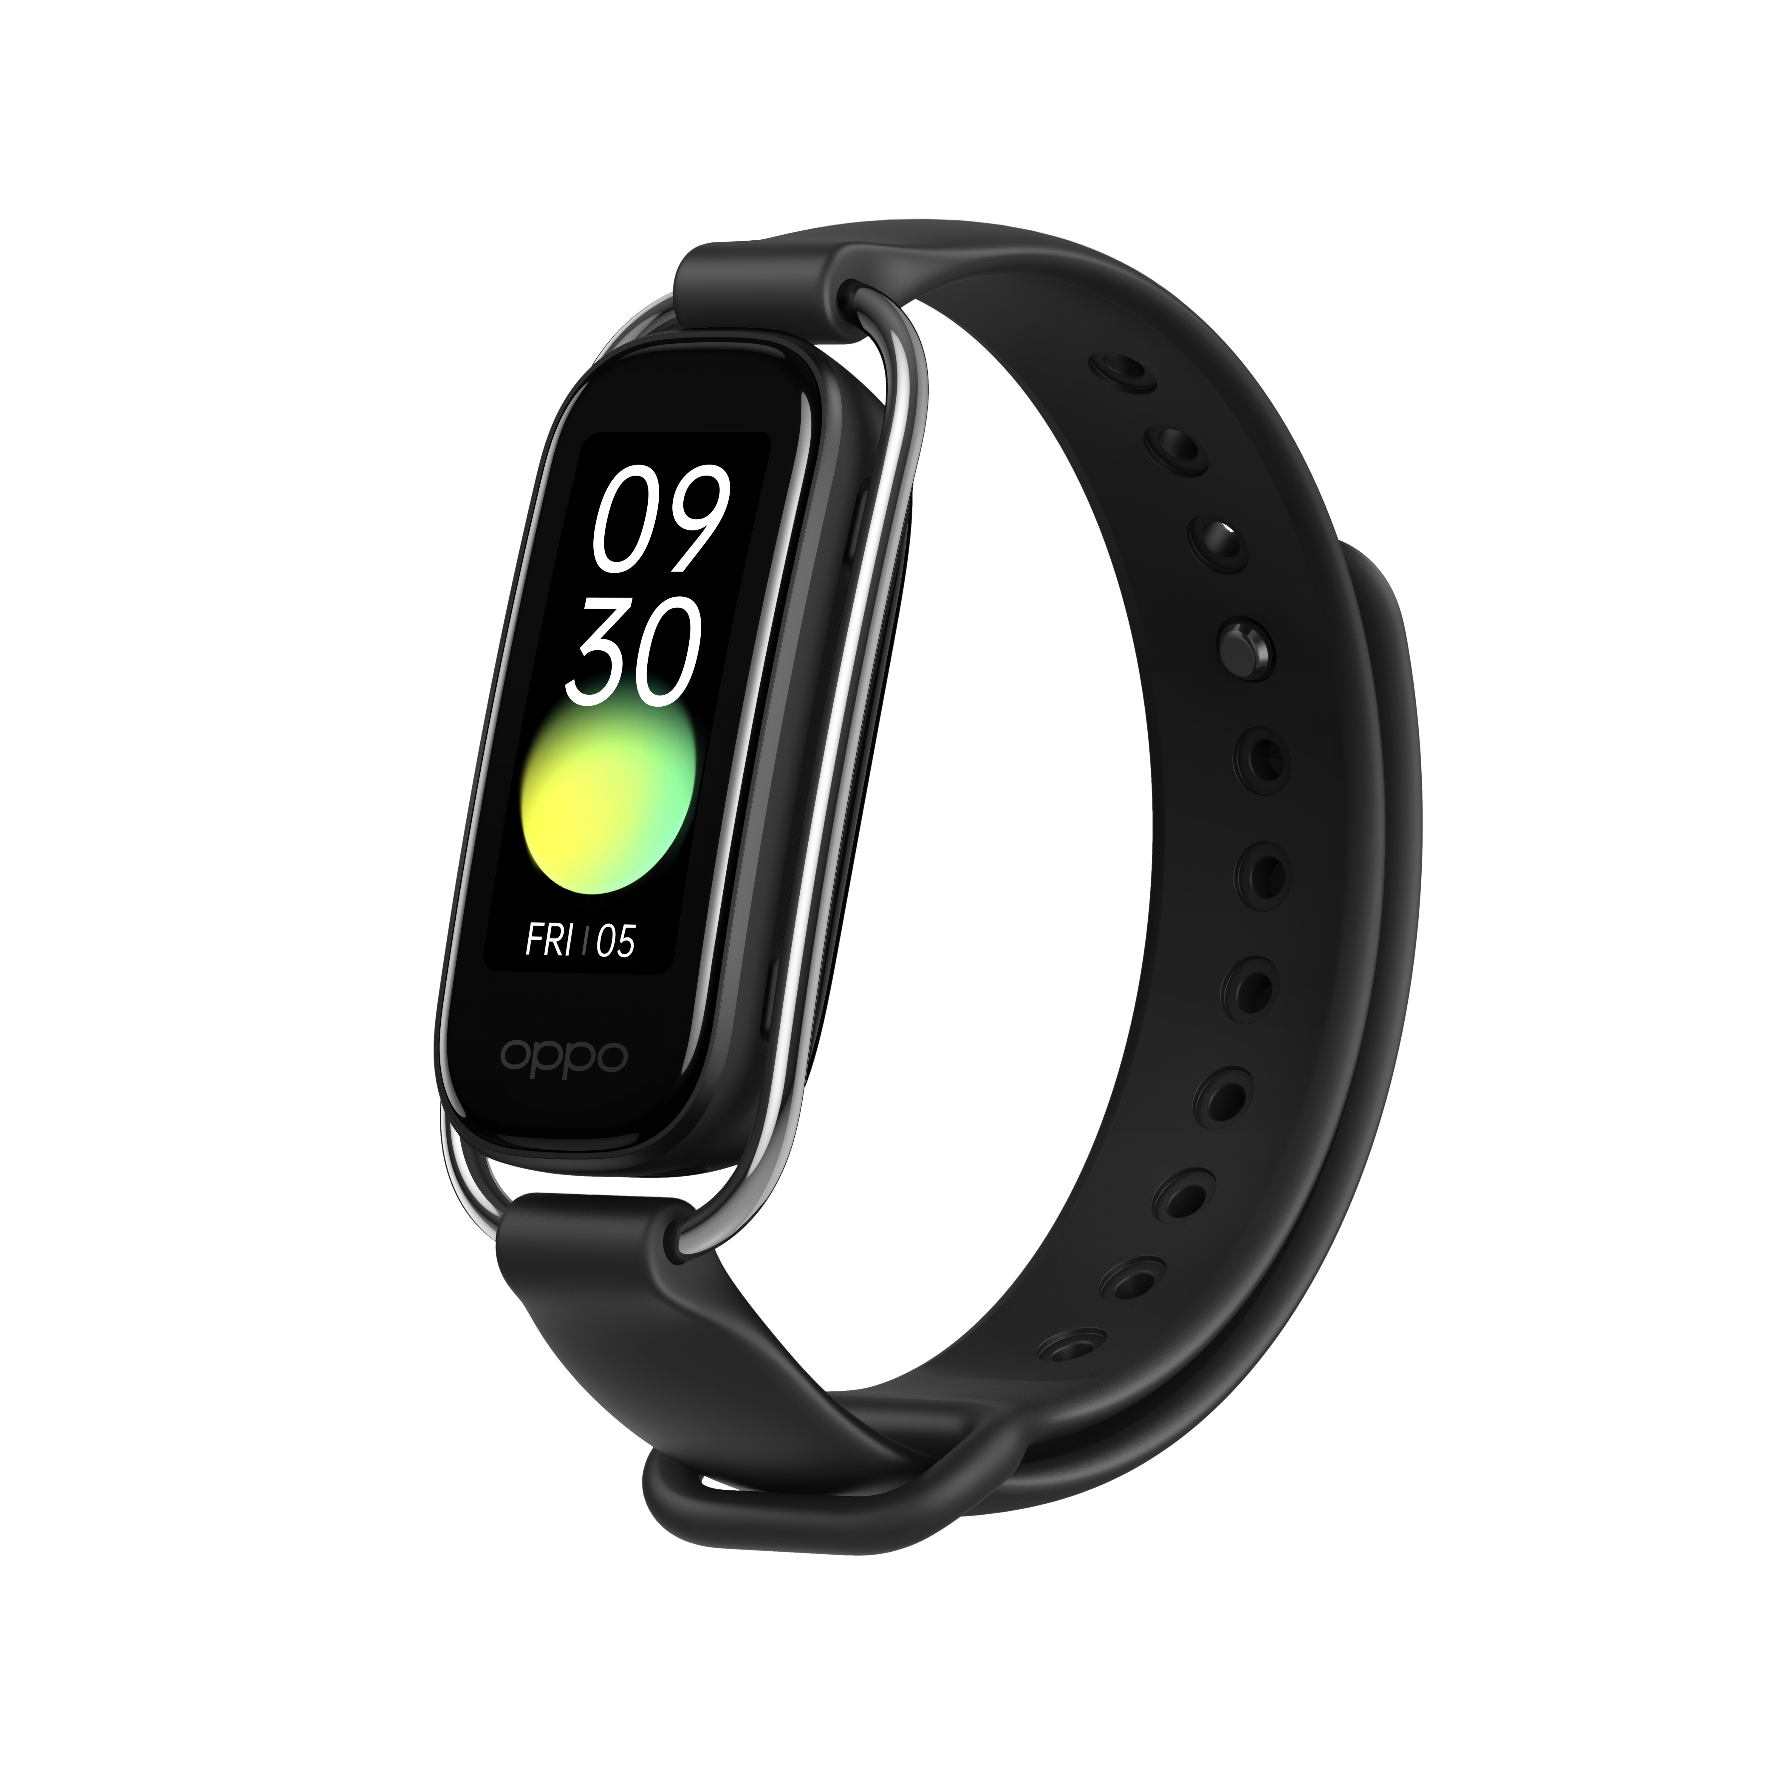

Confidential

Contents
1 Purpose and requirements 2
1.1 Purpose 2
1.2 Requirements 2
2 Product Introduction 3
2.1 Product parameter 3
2.2 Product color, picture 5
2.3 Product SN code identification 6
3. After-sales Guide 7
3.1 After-sales policy 7
3.2 Warranty Instruction 7
3.3 Maintenance Instruction 7
3.4 Warranty Time Specification 7
4 Instructions 8
4.1 Product overview 8
4.2 Change the strap 8
4.3 Power on OPPO Band 9
4.3 Charge OPPO Band 9
4.4 Connect OPPO Band to your phone 9
4.5 Wear OPPO Band 10
4.6 Screen operations 11
5 Function test 11
5.1 Band charging check test 11
5.2 Function test 11
5.3 Heart rate function test 11

1 Purpose and requirements

1.1 Purpose
This article introduces the OPPO Band product parameters, instructions for use, and after-sales policy to guide the customer service center to correctly handle the after-sales work of the product.

1.2 Requirements
The customer service center must operate in strict accordance with the after-sales policy and order recording specifications.

2 Product Introduction

2.1 Product parameter
 | OPPO Band Style | OPPO Band
Colors | Black, Vanilla | Black, Lavender
Dimensions | 40.4mm x 17.6mm x 11.45mm
Dimensions | (11.95mm including heart rate sensor)
Case Materials | Front: 2.5D Glass
Case Materials | Back: PC
Strap Materials | Style Strap-metal Buckle: Stainless Steel | Strap: TPU Band + Aluminum Alloy Clasp
Strap Materials | Style Strap: Fluor Rubber Band + Aluminum Alloy Clasp | Strap: TPU Band + Aluminum Alloy Clasp
Strap Materials | Strap: TPU Band + Aluminum Alloy Clasp | Strap: TPU Band + Aluminum Alloy Clasp
Strap Type | Flexible
Adjustable Strap Length | 130–205mm Around the Wrist
Strap Width | 14mm | 15mm
Suitable Wrist Circumference | 130–205mm
Approx. Weight | 10.3g (not including strap)
Buttons | None
Screen Type | AMOLED
Screen Size | 1.1"
Resolution | 126 x 294
Battery Capacity | 100mAh
Required Adapter Power | 5V 200mA or higher
Charging Method | Contact
Battery Life Based on Typical Use | About 14 days
Supported Operating Systems | Android 6.0 or higher
Chip | Apollo3
Storage | 16 MB
Bluetooth Version | BLE 5.0
Sensors | 3-Axis Acceleration sensor, Optical heart rate sensor, Optical SpO2 sensor
Exercise Modes | Outdoor Run, Indoor Run, Fat Burn Run, Outdoor Walk, Outdoor Cycling, Indoor Cycling, Elliptical, Rowing, Cricket, Badminton, Swimming, Yoga, Free Training
Health Monitoring Features | Continuous SpO2 Monitoring, Sleep Monitoring, Real-time Heart Rate monitoring, Daily Activity, Get-up Reminders, Breathing Exercises
Water Resistance Rating | 5ATM
Other Features | Message Notifications
Other Features | Incoming Call Notifications
Other Features | Call Rejection
Other Features | Timer/Stopwatch
Other Features | Alarms
Other Features | Weather Forecast
Other Features | Music Playback Control
Other Features | Camera Control
In the Box | OPPO Band x1 | OPPO Band x1
In the Box | Style Strap x1 | Strap x1
In the Box | Strap x1 | Charging Base x1
In the Box | Charging Base x1 | Quick Start Guide x1
In the Box | Quick Start Guide x1 | Safety Guide x1
In the Box | Safety Guide

*Battery capacity, battery life, etc. are measured under OPPO laboratory room temperature (25°C) using OPPO standard chargers. The measured data may vary due to factors such as the use environment and individual differences in the charger.
* Specifications are all laboratory test data.

2.2 Product color, picture
1. OPPO Band
（1）Black
（2）Lavender
2. OPPO Band Style
（1）Black
（2）Vanilla

2.3 Product SN code identification
OPPO Band product SN code information can be queried in the band body, HeyTap Health and the color box, as shown in the red area in below picture:
（1）At the body of the band(Band>Settings>About>SN)
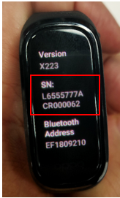
（2）Mobile phone (HeyTap Health>Manage>More>About device >Device serial number
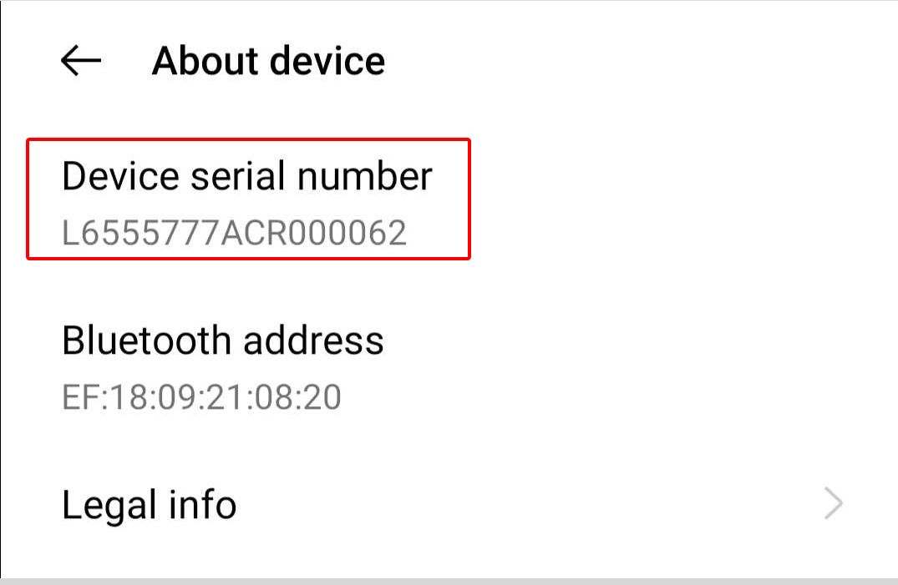
（3）Box
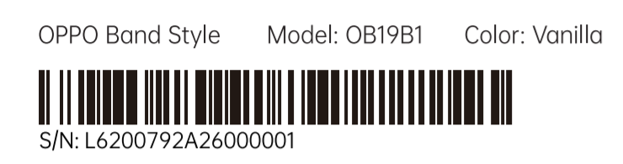

3. After-sales Guide

3.1 After-sales policy
The After-sales policy is implemented in accordance with local regulations.

3.2 Warranty Instruction
① If the OPPO Band body has non-artificial damage and the quality issues of the product itself, the OPPO Band body can be replaced separately in warranty;
② If the Charging base has non-artificial damage and the quality issues of the product itself, the Charging base can be replaced separately in warranty;
③ If the Style\Sport Strap has non-artificial damage and the quality issues of the product itself, the Style\Sport Strap can be replaced separately in warranty.

3.3 Maintenance Instruction
① If the Band body is faulty or missing, the customer can pay for the replacement of the Band body separately.
② If the USB Charging base is faulty or missing, the customer can pay for the replacement of the Charging base separately.
③ If the Style\Sport Strap is faulty or missing, the customer can pay for the replacement of the Strap separately.

3.4 Warranty Time Specification
1. With the purchase invoice, band body, warranty card, packing box or mobile phone HeyTap Health app check the band’s SN, the E-warranty card can be inquired in the WCSM system through SN（Path: WCSM>Basic Data>E-Warranty Card Search>Enter SN>Search）.
2. In the case where the invoice, warranty card, packing box, online purchase record, SN code information query and calculation of the warranty date cannot be provided, No warranty is provided.

4 Instructions

4.1 Product overview
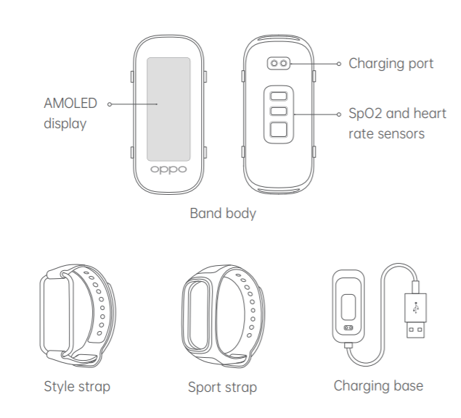

4.2 Change the strap
1.Remove the strap
Hold the strap with both hands and firmly press the display with your thumbs until the band body pops out.
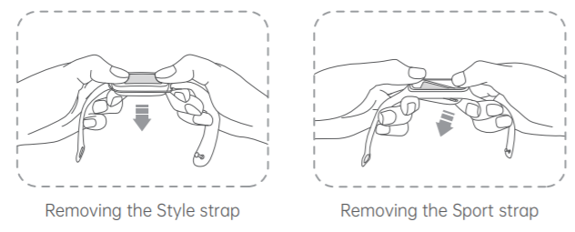
2. Fit the strap
From underneath the strap, insert one end of the band body into the slot in the strap, and then push up on the other end of the body to click it into place.
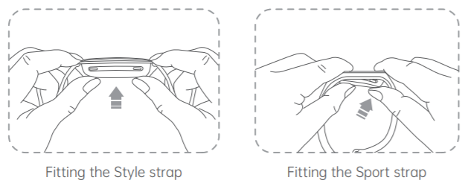

4.3 Power on OPPO Band
OPPO Band powers on automatically when you charge it.

4.4 Charge OPPO Band
Align the charging port of your band with the gold pins on the charging base and click your band into place. The charging icon and battery level will then appear on the band screen.
※ The Sport strap needs to be removed before you can charge your band (the Style strap does not).
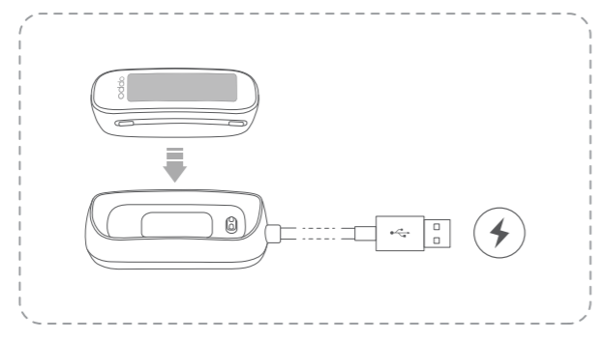

4.5 Connect OPPO Band to your phone
Download the HeyTap Health app
Use your phone to scan the QR code below, or go to your phone's app store to download and install the HeyTap Health app.

Pair OPPO Band with your phone
① Charge your band to power it on. Follow the onscreen instructions and then stay on the pairing screen.
② Open the HeyTap Health app, go to the Manage tab, and then tap Add. Follow the onscreen instructions to finish adding your device.
※ Charge your band to at least 20% to ensure you have enough battery to complete pairing.
※ Throughout the pairing process, keep your phone's Bluetooth on and your band within Bluetooth range.

4.6 Wear OPPO Band
Wear your band a finger's width above your wrist bone. Adjust the strap so that the band feels snug, but not too tight.

Note: Wearing your band too loosely will affect the accuracy of heart rate and SpO2 readings.
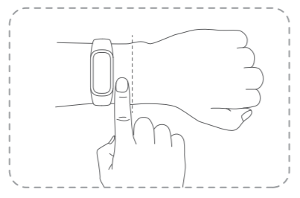

4.7 Screen operations
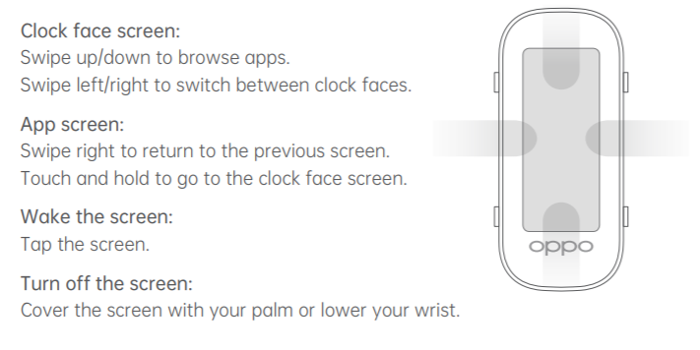

5 Function test

5.1 Band charging check test
Align the charging port of your band with the gold pins on the charging
base and click your band into place. The charging icon and battery level
will then appear on the band screen.

5.2 Function test
When the band is activated,
1. Swipe down or up on the main dial, the bracelet can enter messages, daily activities, exercise, heart rate, blood oxygen, sleep, tools, settings, etc., and all functional modules can respond normally, the the function test Pass.

5.3 Heart rate function test
1. Heart rate test: Wear the band, click on the heart rate, the green heart rate indicator on the back of the band flashes, measure the current heart rate value, after the measurement, the current heart rate value is displayed, then test Pass.

