OPPO Enco Buds Service manual

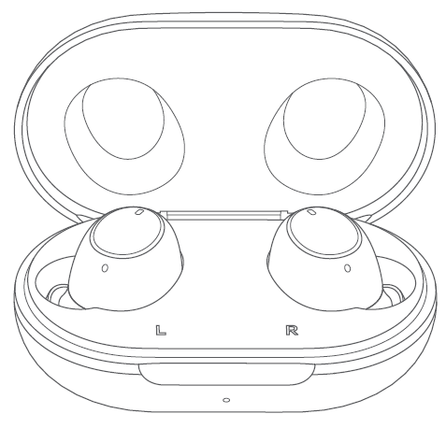

请勿外传
目录
1、Purpose and requirements 2
1.1Purpose 2
1.2 Requirements 2
2、Product Introduction 2
2.1 Overview and packing list 2
2.2 Product color, picture 3
2.3Product SN code identification 3
3、After-sales policy 3
3.1After-sales warranty policy 3
3.2Warranty plan 3
3.3Maintenance proposal 4
3.4Maintenance time specification 4
4、Bluetooth 5
4.1Bluetooth pairing 5
4.2 Auto reconnection 5
4. Pairing with other devices 5
4.4 Headphone wearing detection 5
4.5 Touch controls 6
4.6Charging 7
4.7 Reset to factory settings 7

1、Purpose and requirements

1.1Purpose
This document introduces product parameters, instructions for use, and after-sales policies, and is used to guide the customer service center to correctly handle product after-sales work.

1.2 Requirements
The customer service center must operate in strict accordance with the after-sales policy and record sheet specifications.

2、Product Introduction

2.1 Overview and packing list
This box contains a pair of OPPO Enco Buds, a charging case, 3 pairs of ear tips in different sizes (the size M ear tips come mountedon the earbuds), a quick start guide, and a safety guide.
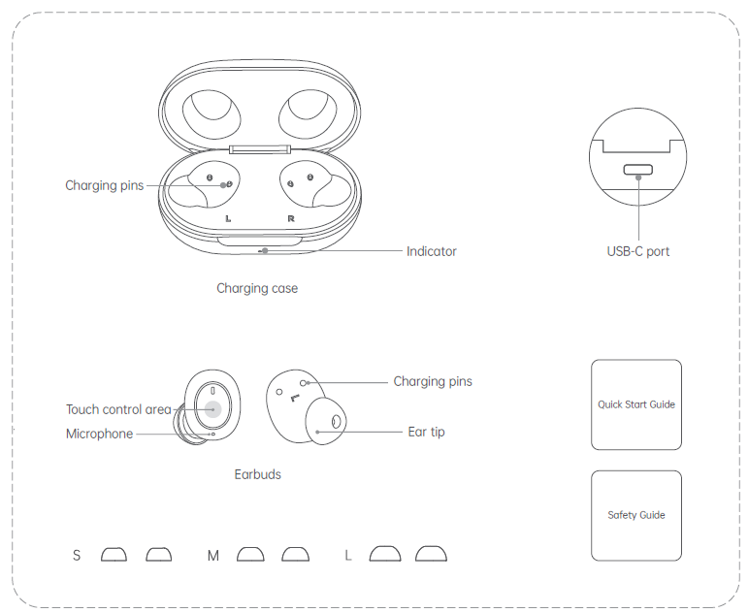

2.2 Product color, picture
white

2.3Product SN code identification
The product SN code information is printed on the packaging box and the headset charging box 2. The SN code information is consistent, as shown in the figure:
（1）Packing box
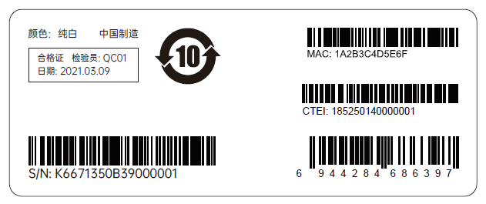
（2）Charging Case
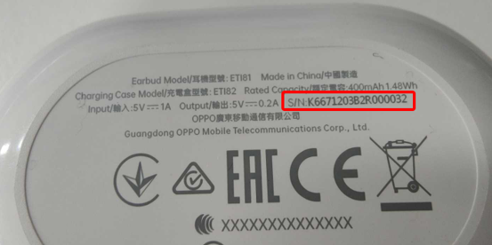

3、After-sales policy

3.1After-sales warranty policy
The after-sales warranty policy is implemented in accordance with local laws and regulations.

3.2Warranty plan
① During the warranty period, if the left earphone is not damaged by humans and has quality problems of the product itself, the left earphone accessories can be replaced separately;
② During the warranty period, if the right earphone is not damaged by humans and has quality problems of the product itself, the right earphone accessories can be replaced separately;
③During the warranty period, if the charging box is not damaged by humans or the quality of the product itself, the charging box accessories can be replaced separately;
④During the warranty period, if the ear caps are not damaged by humans or the quality of the product itself, the ear cap accessories can be replaced separately;
Remarks: The headset is shipped with a complete set of materials, and then disassembled locally to be replaced by the user. The sluggish materials generated later will be written off by the spare parts group and each agent.

3.3Maintenance proposal
①If the left earphone fails or is lost, the left earphone accessories can be replaced separately for a fee;
②If the right earphone fails or is lost, the right earphone accessories can be replaced separately for a separate fee;
③If the charging box fails or is lost, the charging box accessories can be replaced separately at a separate fee;
④In the case of a malfunction or loss of the ear cap, the ear cap accessories can be replaced at a separate fee;
⑤If the USB data line is faulty or lost, the USB data line accessories can be replaced at a separate fee;
Remarks: The headset is shipped with a complete set of materials, and then disassembled locally to be replaced by the user. The sluggish materials generated later will be written off by the spare parts group and each agent.

3.4Maintenance time specification
The after-sales warranty policy is implemented in accordance with local laws and regulations.

4、Bluetooth

4.1Bluetooth pairing
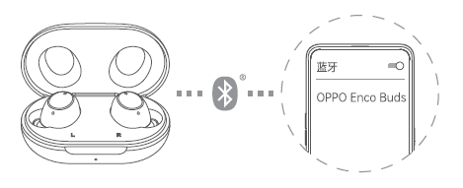
1 If you are using your OPPO Enco Buds for the first time,open the charging case with your earbuds inside. The earbuds will automatically enter pairing mode.
2 Turn on Bluetooth on your phone:
• Regular pairing: Search for and select "OPPO Enco Buds"on your Bluetooth setup page to complete pairing.
• Quick pairing: Hold your OPPO Enco Buds near an OPPO phone that has Bluetooth turned on. A setup prompt will appear on your phone. Complete pairing according to the onscreen prompts.
Note: Only some OPPO phone models support quick pairing. For details,
visit www.oppo.com

4.2 Auto reconnection
After a successful connection, your earbuds will automatically connect to the most recently connected device the next time you open the charging case with the earbuds inside. If reconnection fails, your earbuds will automatically enter pairing mode.

4. Pairing with other devices
To enter pairing mode, turn off Bluetooth for the device your earbuds are connected to, or touch and hold the touch control area of both earbuds for 4 seconds. You will now be able to pair your earbuds with a new device on the device's Bluetooth setup page.

4.4 Headphone wearing detection
no

4.5 Touch controls

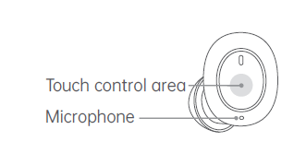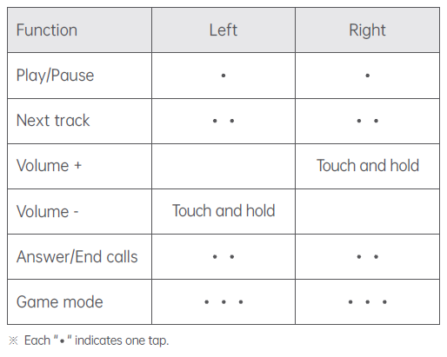

Custom settings
You can customize settings, such as touch controls for the left and right earbuds, on your phone.
For ColorOS devices
Go to "OPPO Enco Buds - EARBUDS FUNCTIONS" on the Bluetooth setup page of your device to customize settings.
※ Available on phones with ColorOS 11.0 and later versions.
For other Android devices
Find the "HeyMelody" app in your app store and install it. You can customize touch settings in the app.
※ Available on phones with Android 6.0 and later versions.
※ Go to the product details page on OPPO's official website to view the list of app stores where the "HeyMelody" app is available.

4.6Charging
Battery level
When your earbuds are inside the charging case, the indicator shows the battery level of the earbuds. When you remove your earbuds from the charging case, the indicator shows the battery level of the charging case itself. Different indicator colors are used to show the battery level. Specifically, red indicates
low, yellow indicates medium, and green indicates full or sufficient.
Charging your earbuds
To charge your earbuds, put them inside the charging case and close the case lid.
Charging the case
Use a standard USB-C charging cable to charge the case. The indicator will light up when charging. Yellow indicates charging in progress, and green indicates charging is complete.
※Make sure the charging pins of the earbuds and charging case are dry andclean before charging. Otherwise, they can be damaged by corrosion.
※Charge the charging case and earbuds regularly. Leaving your earbuds orcharging case fully discharged for more than two months may damagethe battery inside.

4.7 Reset to factory settings
1 Disconnect your earbuds from your device, put them in the charging case, and leave the lid open.
2 Touch and hold the touch control area of either the left or right earbud.When the indicator blinks red three times, your earbuds have been restored to actory settings.

